Picnic Hijli Sharif mazar (2020.01.26)

REPORT:

Picnic is very important part of education system and as per my understanding all students are waiting eagerly for the day of picnic. Our Department of Nutrition also organizes picnic every year. But important thing of this Department is all students will decides that where they want to go 20.01.2020. This time we all are very excited because in a history of Department of Nutrition it happened very first time that we arranged picnic at very far place from The Dargah of Masnad-e-Aala or Hijli Sharif mazar is widely known in this part of Bengal for fulfilling the wishes of the needy. An extensive area situated on the eastern bank of Rasulpur River in the Contai subdivision of East Midnapore district of West Bengal, Hijli has a rich 300-year-old history. Surrounded with woodland and an abandoned shore, today this rural place is called Nijkasba but popularly adorned for Hijli Sharif Dargah or shrine where spiritual miracles are known to happen. All student are very excited for this picnic.

PHOTOS:

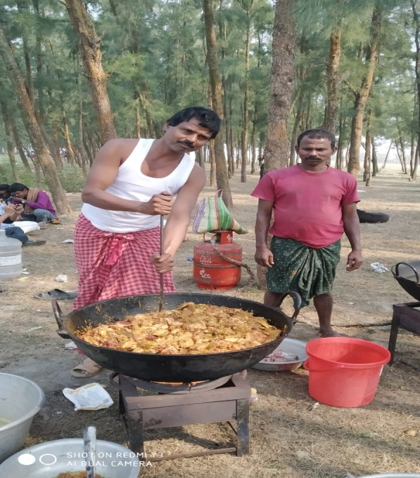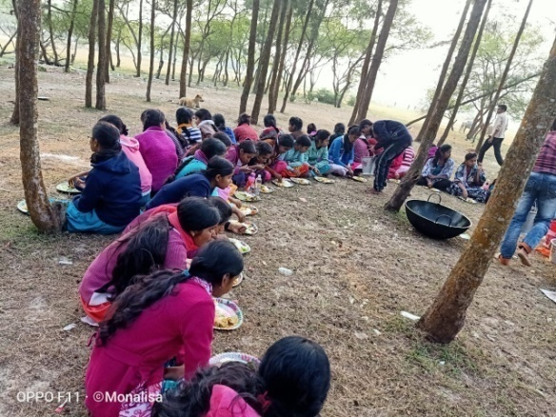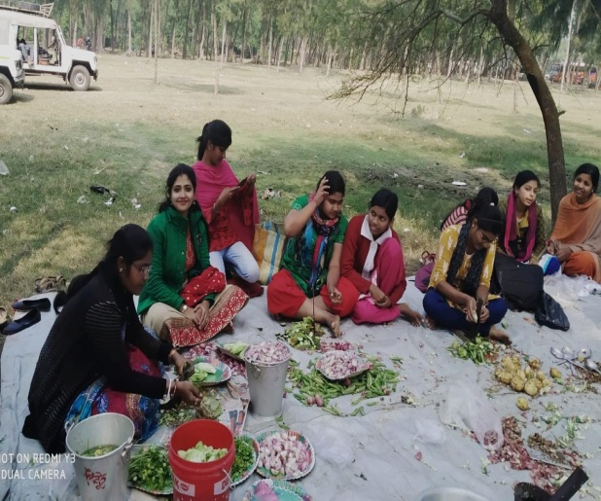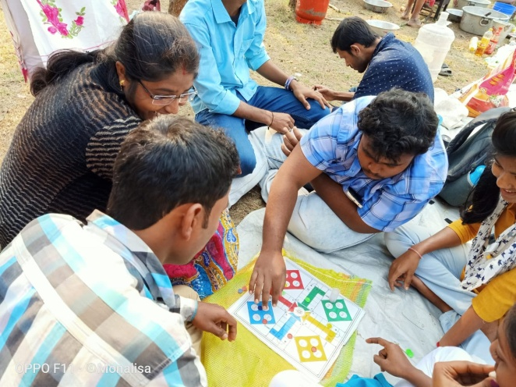

Attendance of Participants:

- Apurba Giri
- Tanmoy Giri
- Prabir Jana
- Monalisa Roy
- Suchata sahoo
- Buddhadev Jana
- Buddhadev Mistri
- Moumita Samanta
- Keya Dash
- Pranati Bera
- Biswajit Das
- Debabarata Giri
- Khokan Chandra Gayen
- Sukanya Bhunia
- Riya Das
- Indrajit Dalai
- Madhumita Das
- Sudesna Khatua
- Sumit Bhunia
- Debdulal Sahoo
- Koushik Mandal
- Madhumanti Pradhan
- Mahasewta Maity
- Prabin Nayak
- Puja Bhunia
- Rakhi Rani Guria
- Ranajit Maity
- Sanjib Das
- Saswati Jana
- Shyam Sundar Gole
- Somashree Patra
- Subha Das
- Sudipta Bera
- Sujata Sasmal
- Sagar Maity
- Nilima Maity
- Sukhendu Bera
- Chiranjit Pal
- Sourav Mistri
- Sougata Acharya
- Surja Kanta Das
- Sumit Patra
- Sukhendu Das
- Prasenjit Pal
- Subhamay Jana
- Pralay Das
- Suman Jana
- Subhajit Paria
- Subrata Ghosh
- Debabrata Pradhan
- Mrinal Kanti Bera
- Arpita Sahoo
- Istayani Jana
- Piyali Nayek
- Nibedita Bera
- Annapurna Majhi
- Sukanya Hui
- Sudipta Das
- Chaitali Das
- Nabarupa Bar
- Sangita Majhi
- Srabani Kotal
- Archana Mandal
- Sanchita Patra
- Parboti Ghorai
- Asit Baran Das
- Aditi Das
- Sayani Ghorai
- Debasri Bhunia
- Anuja Guria
- Chayan Panigrahi
- Aparna Rajak
- Dipshikha Paria
- Kabita Das
- Krishna Jana
- Mousumi Mondal
- Priyanka Samanta
- Rajaram Giri
- Sabitri Bera
- Saheli Jana
- Sangita Hazra
- Shreya Maity(1)
- Shreya Maity(2)
- Sukanta Bhunia
- Srabani Maity
- UmaDolai
- Buddhadev Jana
- Buddhadev Mistri
- Debdulal Sahoo
- Koushik Mandal
- Madhumanti Pradhan
- Mahasewta Maity
- Prabin Nayak
- Puja Bhunia
- Rakhi Rani Guria
- Ranajit Maity
- Sanjib Das
- Saswati Jana
- ShyamSundar Gole
- Somashree Patra
- Subha Das
- Sayan Das
- Sudipta Bera
- Sujata Sasmal
- Sagar Maity
- Nilima Maity
- Sukhendu Bera
- Chiranjit Pal
- Sourav Mistri
- Sougata Acharya
- Surja Kanta Das
- Sumit Patra
- Sukhendu Das
- Prasenjit Pal
- Subhamay Jana
- Pralay Das
- Suman Jana
- Subrata Ghosh
- Debabrata Pradhan
- Mrinal Kanti Bera

RESOLUTION:
1. Picnics give us an opportunity to escape from the daily routine and help us open up more with respect to our feelings albeit in a relaxed atmosphere.
2. College picnic provides a great opportunity for students to cherish wonderful experience and face a range of challenges that can contribute significantly to their personal development.
3. Important that students must participate in the picnics as it provides a holistic education.
4. They definitely do foster better mental health in the long run because if you share with your family, you feel that much closer to them in reality.

